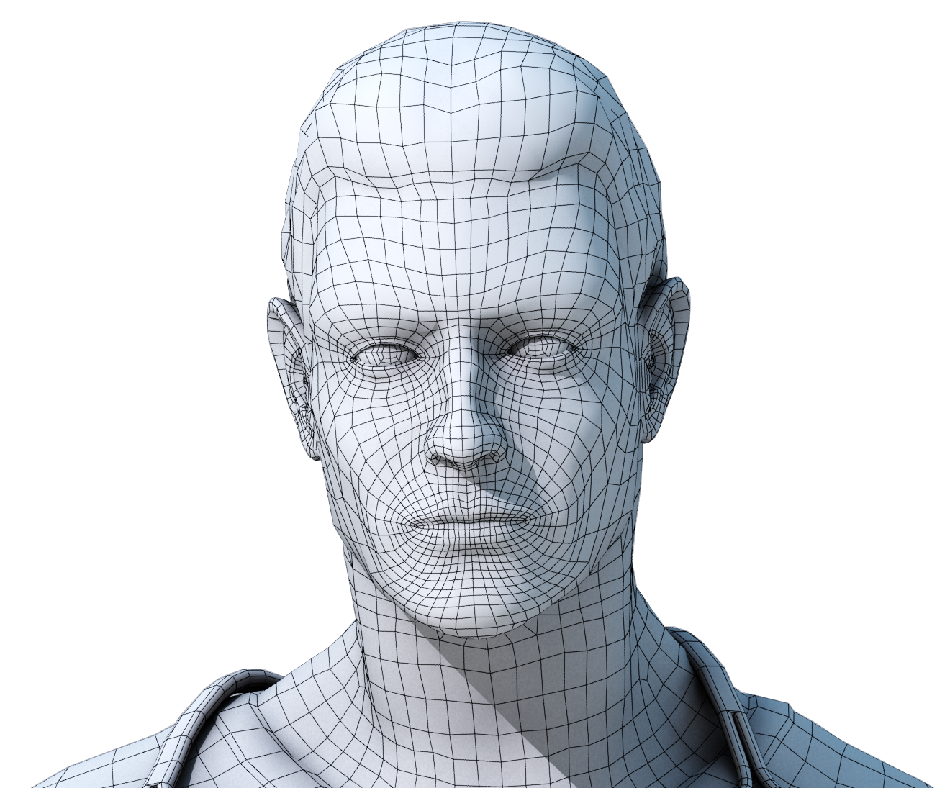

# Face Recognition Attendance System

**M.Ihsan**

**20117398**

**CL/BScSD/13/38**

**Contents**

Introduction 2

Problem Statement 4

Proposed Solution 5

Literature Review 6

Feasibility Study 8

Technical Feasibility 8

Scope Feasibility 9

Time Feasibility 9

Project Description 10

The Technology That Have Been Used 10

System is Very Simple and Reliable 10

How it Works? 10

Resources Required 13

MS Packages 13

MS Word 2016 13

MS Visio 2016 13

MS Project 2016 13

MATLAB 13

Expected Output and Outcome 14

Time Plan for Implementation 15

Conclusion 16

References 17

**Introduction**

The face recognition system is a noteworthy created framework which is utilized by the entire universe for various purposes. This distinguishes a specific individual by the stored pictures as in categorizes how the individual looks like, so if his information is put away, he will be offered access to the framework in which he needs to get in addition to on the off chance that he isn't perceived by the framework, he won't be.

As I mentioned above as per the proposal for the final project, I have picked the topic as a face recognition system which recognizes person's face by the stored information which has been in the framework. The example taken further on this topic will be of the Holborn Assets situated in the Colombo. The framework which is utilized right now is a fingerprint system, in which there such a large number of things which could turn out unexpected, that likewise the unique finger impression frameworks are utilized just in the principle branch. Since this is the entire power leading group of Sri Lanka, there are such huge numbers of branches all throughout the nation. Furthermore, in alternate branches, they utilize a manual framework which is somewhat obsolete these days, and extremely hard to deal with. Concurring what the officers said there was, this framework currently is bit hard to deal with and furthermore even the IT division of the primary branch is proposing if it's a facial recognition framework is actualized for the participation, that would be considerably less demanding to compute their pay and constantly and all resemble caught precisely

As the introduction of the framework "Face recognition", these are for the most part utilized for security purposes in the early days, however now this is some least demanding way that have been utilized as a part of various sort of strategies. Nowadays for some portable instalments and airport security they utilize this framework, With regards to perceiving faces, it distinguishes a human face with 80 nodal focuses. It not only catches the face but also creates a unique technique with the nodal.

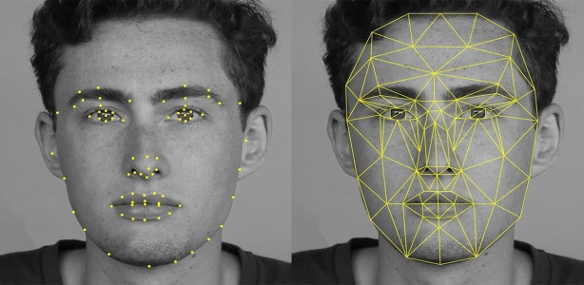

Like the above picture, that is the way the framework perceives the human face with nodal focuses. What the nodal point in actual does is for instance taking twins working in a similar organization in consideration. This utilizes to gauge the variable focuses, width of the parts that what confront contains, wrinkles, cheeks and so on. In simple it helps to identity that the person is in a form of digital images. In other countries as such the USA according to the CBS news, the country database uses this face recognition system so why not Sri Lanka brings about this?

**Problem Statement**

Up to date, the issue in the 21st century is, regardless we haven't proceeded onward to the present century from the past twentieth century. The pitiful truth is, just the created nations are taking points of interest of the most up to date advances which have been acquainted time to time, however the creating nations are really not which is unreasonable. What issue was recognized here is Holborn Assets needed to make their participation framework computerized. As of now what it has is, the primary branch, an eye discovery which is highly computerized when it’s contrasted with alternate frameworks we have in Sri Lanka. Be that as it may, alternate branches throughout the nation, a few have unique mark framework (fingerprint), and a few have a manual strategy, a mark framework which is so difficult to oversee and keep up. Indeed, even this is distinguished as an issue since the framework isn't robotized. Presently a long ways past that, the issue what has been recognized personally is, since the framework is manual, the staffs can simply give a signature and misuse it Yet, it doesn't mean the specific individual from the staff have to keep proof after use. Indeed, even his companion from a similar office can put his signatures without the individual being present there. Yet he will be distinguished as a man who sought work despite the fact that he truly didn't. In this way, my point is if ten staffs do this for a month in a specific branch, in like manner it will at any rate happen everywhere throughout the nation. So how many amounts of misfortune will the Sri Lankan government needs to confront? This is some significant issue. Like for an illustration, this even occurred in India years back, and afterwards they had thought of a similar arrangement, executing a computerized confront recognition framework, leading to an issue of money. When the framework is manual, they can attempt an indistinguishable thing from what I have said above, such as asking to keep the mark from another person, and they'll be considered in the event that they have worked additional time. Thus, they'll be paid more. A similar sort of misrepresentation will happen with regards of short leave or half day, the mark can be kept by another person, and the specific staff will be considered present as if he worked the entire day. Who needs to acknowledge the misfortune what occurs here? Certainly the administration. Along these lines, this has been distinguished as the issue in the Holborn Assets, there concocting an answer is an absolute necessity here.

**Proposed Solution**

Agreement to the issue explanation which have been expressed above Holborn Assets needs to change its participation framework which is currently present. At the point come to the equipment it won't cost them as much as the unique mark framework or some other mechanized frameworks would, excluding the Manual framework because it won't cost in any case when it’s contrasted with computerized frameworks. These frameworks help us to keep up the entire participation framework and keep it reason like exact. Additionally, what the innovation will be utilized here is "Neural Networks" which is a manmade brainpower philosophy from which every one of these procedures will be simple as what we have expected and what our customer "Holborn Assets" needed.

At a few focuses, individuals do even execute facial recognition framework and unique finger impression framework both in the associations. In any case, our customer is simply Holborn Assets, along these lines of participation framework which just perceives the face.

Since there resembles more than 50 individuals work in a specific branch in Colombo and in the close by regions, the different branches it relies upon the general population live in the specific zone, the proposed arrangement ought to be quick and exceptionally straightforward. This robotizes the staffs’ login times and their participation by the computerized reasoning strategy that we have actualized here. It catches every last representative's work hours and stores it to the back end. The administrators can arrange workers in the participation administration framework into a table format ordering with the staff and timings. It can make the entire organization forms a considerable measure less demanding.

In the last Its coding gives a report before the month is over, similar to a participation framework report with all the participation details as in the timings of their duration at work to what extent they have taken breaks every day, their working hours, in like manner it will be sifted by the way we ordered them and present the entire answer to the chief. This above is possible after the utilizing of the face recognition system that we will execute including the framework itself which will be basic as it clarified previously.

**Literature Review**

This is a research (Face Recognition) which is a main developing problem when it comes to train system with countless images. This is because facial recognition has some influence everywhere in the developed countries, regardless of any other system being used, facial recognition system will be with the concept of artificial intelligence. For instance, in order to prevent the frauds of ATM in India, it is recommended to prepare the database of all ATM customers with the banks in India & deployment of high resolution camera and face recognition software at all ATMs. Thereby whenever the user will enter in ATM his photograph will be taken to permit the access after it is being matched with the stored photo from the database. Where there is an ATM, a face recognition system is there. Similarly, extortion investigator framework which CBI utilizes as a part of the India, Security observing from the significant organizations, wherever there's a face recognition framework comes.

Presently the world begins to think about the components that made this face recognition system to develop. The significance, the impact and so forth this is on the grounds that the dynamic improvement of calculation, additionally we can get an extensive database just where there are such a large number of facial recognition computerized pictures. This counterfeit neural system strategy has the capacity of a human mind so distinguishing or perceiving a man's face.

A case in 1996, Rowley and group exhibited face detection system in view of a retinal associated neural system which analyzes little windows of a picture to choose whether every window contains a face. For this procedure, they have utilized a bootstrap calculation so as to take out troublesome errands of physically choosing preparing cases, yet not faces.

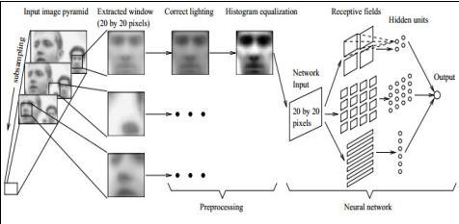

The above picture demonstrates their correct test, first time it was tried with a picture of a window. At that point the window went through neural system, where it begins to detect the window picture, a face.

Safe house International Limited, an Australian organization, protected programming including face recognition systems. The organization asserted this framework could track moving individuals and compute the quantity of individuals in a group. After 9/11, the product was considered "financially appealing" by the US organization. In like manner, what is told above is retinal associated neural system. At that point there's quick neural system. Neural systems technique to decrease the calculation time for finding human countenances. Each picture is isolated into little sub pictures and afterwards everyone is tried independently utilizing a quick ANN. The test aftereffects of examination with traditional neural systems demonstrated that the rapid is accomplished while applying FNN.

Then again, social medias, for the most part Facebook utilizes another innovation which is specified as "deep Face", when a client transfers a picture of him, a performance picture, or with his companions, this way it effortlessly recognizes those individuals who are in the specific photograph so it will be convenient to tag those in other pictures

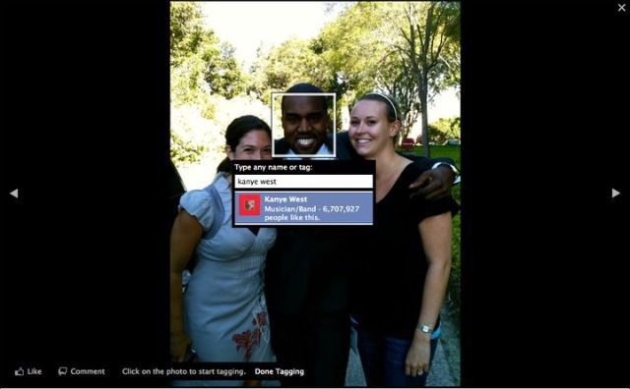

Above strategy was one of the counterfeit consciousness methods which I specified, DeepFace. The individual's Facebook ID comes directly after when the cursor is moved close to his face. Prior to these profound strategies were presented, web-based social networking applications were utilizing some unique sort of face recognition frameworks. With regards to social Medias, Facebook has seen very change in this DeepFace method other than any social Medias. Indeed, even this additionally goes under the face recognition utilizing neural system.

**Feasibility Study**

This is something that investigators whether it's conceivable to execute the new framework as per the customer's prerequisite. In the event that it is acceptsble, the proposed arrangement will be executed. If not, the creating group will locate an option or will quit making the following stride. To complete this report a few variables ought to be considered. Those are;

• Scope Feasibility

• Economic Feasibility

• Social Feasibility

**Technical Feasibility**

This is the principal period of investigating a venture, the degree to which the framework can be effectively planned, created, and introduced by the IT gathering. In this first stage, the designers should confirm if they can conquer the snags that they have of building the framework and finish the entire framework as per customer's prerequisite.

So here when the creating group anticipates utilizing another innovation for the framework, risk increments intensely when the innovation itself is new. Task estimate is an imperative thought, regardless of whether estimated as the quantity of individuals on the improvement group, the period of time it will take to finish the undertaking or on the other hand the quantity of unmistakable highlights in the framework. Larger ventures display more hazard, since they are more confused to oversee and on the grounds that there is a more prominent shot that some critical framework necessities will be disregarded.

The degree to which the task is profoundly coordinated with different frameworks can cause issues, since intricacy is expanded when numerous frameworks must cooperate.

In the end, venture groups need to consider the similarity of the proposed arrangement with the innovation that officially connected on the present framework. New innovation and applications should have the capacity to coordinate with the current condition for some reasons. They may depend on information from existing frameworks, they may create information that nourishes different applications, and they may need to utilize the organization's current interchanges foundation.

**Scope Feasibility**

The extension achievability chiefly focuses on the extent of the task. By directing this possibility, it gives a legitimate thought of how the undertaking will function, with a specific end goal to accomplish this task what are the things that must be taken after moreover heaps of thing will be shrouded in scope plausibility.

Likewise, this for the most part about the motivation behind the framework be made or a framework substitution by an old framework to new one simply like what occurs here. Old manual framework to new computerize confront recognition framework utilizing manmade brainpower methods.

**Time Feasibility**

Time is Gold, as the precept says; things ought to be secured inside the due date which is allotted by the venture director. Since in this true, on the off chance that we aren't productive to our customers, we will be supplanted by one of our rivals.

A straightforward methodology of the market presently for this situation, our customer Holborn Assets is in a rush that they require a framework as quickly as time permits to supplant their old manual framework. In this manner, time plausibility ought to be directed here and complete the venture at the earliest opportunity and before the due date.

**Project Description**

**The Technology That Have Been Used**

Holborn Assets has to change its attendance system with a face recognition attendance system with artificial intelligence techniques – neural networks. When it’s come to the equipment it won’t cost them as much as the finger prints system or any other automated systems. These systems help us to maintain the whole attendance system and keep it purposes accurately. Also, what the technology is going to be used here is “Neural Networks” which is an artificial intelligence methodology from which all these processes become easy as what we have expected.

The below flow diagram will demonstrate the workflow of the proposed Face recognition System.

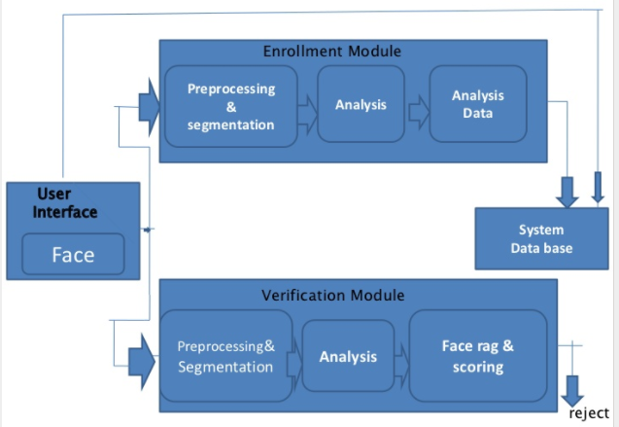

**System is Very Simple and Reliable**

Since there resemble more than fifty individuals working in a specific branch in Colombo and some close by zones and different branches it relies upon the general population living in the specific zone, the proposed is quick and extremely straightforward.

**How it Works?**

This mechanizes staff login times and their participation by the artificial intelligence procedure that we have actualized here. It catches every last representative's work hours and stores it to the back end. The administrators can arrange workers in the participation administration framework into ordering with the staff composes can make the entire organization forms a great deal simpler. We can without much of a stretch say it perceives the staffs faces with artificial neural network method, and enable them to work with catching the time that when he goes into the workplace and when does he take off. Later on, it can be produced as towards the end of the month, it gives a participation framework report with all the participation rundown including the timings of work utilizing this face recognition framework that we will actualize, the time they signed into the frameworks, to what extent they have taken breaks every day, their working hours, in like manner it will be separated by the way we ordered them and present the entire answer to the chief. Indeed, even the framework will be straightforward as it clarified previously.

**System Architecture**



**Deliverables**

In this part, I was solicited to portray the yield from the task. These will incorporate the outcomes, any antiquity, or a detail investigation of the subject. The outcome what we will arrive is, as I said from the above undertakings, this is where heaps of individuals work in Sri Lanka everywhere throughout the nation, we anticipate that the arrangement will be quick, straightforward and the most effective one as all expect how a framework should function.

What we expect as a yield from the task may be, the framework ought to enable the specific staff to go into the workplace additionally the time that they're signing into the framework which helps the organization human asset administration to ascertain that to what extent that they have been working for the day, so the amount they have ought to be paid for the month if the compensation giving strategy is month to month premise, in like manner we can expect such a large number of yield from the venture.

Despite the fact that there are numerous frameworks accessible in the market which perceives the specific individual and gives him access to something, how this framework ends up noticeably one of a kind is the procedure that have been utilized here, the Neural Network. It takes in itself from the information we give and perceives this is who the individual is as per the framework that I will configure, underneath pictures are the data sources that I give, and the framework itself learns and perceive the individual and permits him.

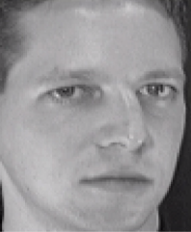

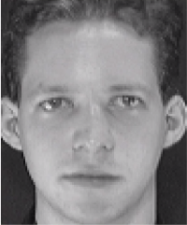

**Resources Required**

To manufacture and execute the present framework, I require a few applications to finish the entire undertaking. What's specified here is, for the documentation and the framework for the entire procedures and so on.

**MS Packages**

**MS Word 2016**

So as, to write entire content related archives, I need MS Word for the task. With regards to a building up a framework it's not just about building up the framework. Yet additionally, the documentations as well likewise assume a noteworthy part when creating frameworks. That is the manner by which a task finishes like generally speaking. So as to make the undertaking documentation flawless, I have picked MS Word when other programming likewise exists to type these documentations.

**MS Visio 2016**

This is from a similar bundle from Microsoft from which I needed MS Word; however the reason for utilizing the application is entirely unexpected. Microsoft Visio is utilized for creating bound together displaying dialect charts (UML Diagrams) we require Microsoft Visio to make our procedure simple. We have to create UML graphs, for example, utilize case outline, class chart and ER charts. These charts give individuals an appropriate thought that the procedure of the framework.

**MS Project 2016**

As I said above, time is gold. With a specific end goal to keep up the time administration, we require MS venture for our documentations. Likewise this is a task administration programming item, created and sold by Microsoft. It is intended to help an undertaking supervisor in building up an arrangement, doling out assets to assignments, following advancement, dealing with the financial plan, and dissecting workloads. Why we use here it is basically, dealing with the time.

**MATLAB**

This joins a work area condition tuned for iterative examination and configuration forms with a programming dialect that communicates framework and exhibit arithmetic straightforwardly. Likewise, this is the principle application we require with a specific end goal to build up the framework too. Also, this is a product which is being utilized for the most part for computerized reasoning purposes.

**Expected Output and Outcome**

Expected yield are the outcomes which happens without even a moment's pause when the framework is actualized. Thus, as indicated by the arrangement that I recommend here, the normal yield will be the participation framework which won't be a wreck any longer. It would resemble a report created, simple as the way it’s depicted previously. The issue is, the point at which the framework is executed, a few challenges may occur since the staffs who aren't PC ignorant may think that it’s hard to utilize, yet directly after a workshop or an exhibition, similar to a preparation or a demo session, they may comprehend this as the structure that the framework is therefore means by which it will work.

Then again, what is the normal result? How it varies from expected yield? Expected results will be considered as mid-term comes about. These sorts of results won't be viewed when the framework is executed. This may set aside the opportunity to see the real outcomes. Be that as it may, at that point after now and again will have the capacity to see the progressions at the ground level due to the undertaking movement, and that is the place it is named as a result. At the point when the staffs tend to continue utilizing a similar application, without a doubt in a few months the framework will be executed everywhere throughout the Sri Lanka. Furthermore it can make an entire insurgency island wide in robotized frameworks where alternate associations additionally may take after.

**Time Plan for Implementation**

**Conclusion**

This proposition incorporates everything about the recommended arrangements – Automated face recognition participation framework for Holborn Assets utilizing ANN (Artificial Neural Network). Since the Holborn Assets has a manual participation framework, I have addressed a staff Mr Dinuka, who works at a branch at Nawala. He expressed that lone the fundamental branch which is in Colombo fortification has the mechanized participation framework utilizing unique finger impression hardware, however not alternate branches. This is a noteworthy issue which the entire Sri Lankan government has been confronting, in light of the fact that there even are staffs that simply keep their mark and stamp the time that they have gone to the workplace as they need which appears to be so negative. Along these lines, we thought of an answer that this framework even notes the time that when the staff has gone to the workplace and the time that when he clears out.

In addition, the normal results and yields have been completely portrayed. The present circumstance of the participation arrangement of Holborn Assets, which is recognized as an issue thereby we should give an answer, so even an answer additionally, has been recommended. What's more, practicalities which is additionally a spine of the undertaking support and how it ought to be finished everything is all around clarified. At last, with regards to the framework, the database will be reached out as the staffs sum be that as it may; the framework makes the procedure simple

**References**

Face recognition using neural network. 2017. *Face recognition using neural network.* [ONLINE] Available at: <http://neuroph.sourceforge.net/tutorials/FaceRecognition/FaceRecognitionUsingNeuralNetwork.html>. [Accessed 02 Feb 2018].

Funds for NGOs. 2017. *What is the difference between outputs and outcomes? - Funds for NGOs*. [ONLINE] Available at: <https://www.fundsforngos.org/free-resources-for-ngos/defining-project-results-proposal-difference-outputs-outcomes/>. [Accessed 03 Feb 2018].

Face recognition using artificial neural network. 2017. *Face recognition using artificial neural network*. [ONLINE] Available at: <https://www.slideshare.net/sumeetsumit/face-recognition-using-artificial-neural-network>. [Accessed 03 Feb 2018].

IEEE Spectrum: Technology, Engineering, and Science News. 2017. *Facebook’s Face Recognition Tech Goes on Trial - IEEE Spectrum*. [ONLINE] Available at: <http://spectrum.ieee.org/biomedical/imaging/facebooks-face-recognition-tech-goes-on-trial>. [Accessed 04 Feb 2018].